**ABSTRACT**

Music sharing is one of the most important components in interactive entertainment. In recent years, mobile music market has experience a rapid growth. Current mainstream music sharing platforms provide users with a large number of online music, which however suffer some limitations of functionality since they neglect the interactions in the physical world. The combination of online music sharing and offline music sharing creates a new music sharing mode. The proposed music sharing platform is developed with cloud computing techniques, which relies on sharing of resources and focuses on maximizing the effectiveness of the shared resources. Music sharing on cloud is more convenient and efficient in this case. Experimental results show that this platform can function properly and achieve satisfactory user experience. The purpose of Online Music Portal is to automate the existing manual system by the help of computerized requirements and full-fledged computer software, fulfilling their requirements, so that their valuable data/information can be stored for a longer period with easy accessing and manipulation of the same. The required software and hardware are easily available and easy to work.

**(CHAPTER 1)**

**1.INTRODUCTION**

* 1. **Overview**

Music sharing App is a powerful music sharing software that allows users to log into the system, add albums, and add songs to the playlist. All songs listened to by other users registered on the system can also be found in the album. This music software also has music download capabilities, allowing users to listen to music even when they are not connected to the internet. Any user can register for free, and they can all share their music. One of the most important advantages of an Online Music Website is the capability to customize the web site for each visitor based on his or her preferences, or based on data gathered from other visitors with similar preferences. In Song recommendations system, additional songs are suggested to an individual visitor in a clever way.[1]

Music Sharing App is a powerful music sharing software that allows users to log into the system, add albums, and add songs to the playlist. All songs listened to by other users registered on the system can also be found in the album. This music software also has music download capabilities, allowing users to listen to music even when they are not connected to the internet. Any user can register for free, and they can all share their music.[2]

With increasing demand of information and data. Information Technology is a field which is developing rapidly. Technology which is in demand today might get redundant in future. So, it necessary to provide the latest and most modern IT solutions to various business and other institutions. The objective of this project is to implement Online Music web application with user interface. The motivation of this project comes from my desire to learn the increasingly growing field of Jingo server database designing, website designing and their growing popularity by taking up this Project. The word "design" in the context of a Web Application can mean many things. Its most popular usage probably refers to the visual and user interface (UI) design of a website. This project covers the following implementations:[3]

1) An online product catalogue that can be browsed: The work starts with adding many new product catalogue features which includes displaying categories, products, and product details.[4]

2) Searching the Catalogue: For the visual part, a text box is used in which the visitor can enter one or more words to search through the product catalogue. In Online Music Website, the words entered by the visitor are searched for in the songs' names and descriptions.[5]

3) Handling Customer Accounts: In customer account system, details such as credit card numbers are stored in a database so that customers don't have to retype this information each time they place an order. Customers can log in via a login page or dialog box to get access to secured areas of the web site.The creation, distribution and licensing of sound recordings is referred to as ‘recorded music’. Record companies: (a) sign and provide services to develop artists; and/or (b) distribute and license rights in the sound recordings created by artists to retailers. 2.4 The music industry also includes ‘music publishing’, where companies: (a) sign and provide services to develop songwriters; and (b) manage and license the rights in their musical compositions (‘songs’), including when sound recordings of the songs are played.[6]

The main motivation for this system is to enable users to share contents, in this case music files stored in the mobile devices, in real-time (the system could be extended to work for video, images and more). Typical venues to setup such a system may be public places where people gather for entertainment, such as bars and clubs, and in private homes.

1. **User Interface (UI):** The UI of the platform is crucial for attracting and retaining users. It should be intuitive, visually appealing, and easy to navigate. Users should be able to search for music, browse playlists, and access their account settings effortlessly.
2. **Music Library:** The platform should offer a vast and diverse music library, including songs from various genres, artists, and languages. It should also provide advanced search and filtering options to help users find specific tracks or artists easily.
3. **Streaming Quality:** High-quality audio streaming is essential to ensure an enjoyable listening experience for users. The platform should support different streaming qualities and provide options for users to adjust settings based on their internet connection.
4. **Social Features:** Social features such as user profiles, following/follower mechanisms, and the ability to create and share playlists enhance user engagement. Users should be able to connect with friends, discover new music through recommendations, and share their favorite tracks seamlessly.
5. **Personalization:** Personalized recommendations based on user preferences, listening history, and behavior help improve user satisfaction and retention. The platform should employ algorithms to suggest relevant music, playlists, and artists tailored to each user's tastes
6. **Accessibility:** The platform should be accessible across various devices and operating systems, including desktops, laptops, smartphones, and tablets. Native mobile apps for iOS and Android platforms can further enhance accessibility and user experience.
7. **Legal Compliance:** Ensuring that the platform complies with copyright laws and licensing agreements is crucial to avoid legal issues. Proper licensing agreements with record labels, artists, and copyright organizations should be in place to stream and share music legally.
8. **Security and Privacy:** Protecting user data, maintaining secure payment gateways, and implementing robust security measures to prevent unauthorized access and data breaches are essential aspects of any online platform.

Overall, an effective Online Music Sharing Platform should prioritize user experience, content diversity, legal compliance, and monetization strategies to succeed in the competitive digital music industry. Regular updates, user feedback, and innovation are key to staying relevant and maintaining user engagement over time.

There are several ways to illegally download music and offenses: software piracy, copyright, theft, piracy, file-sharing (electronic and/or non-electronic methods), and free activation. Softcopying – copying digital files such as music or movies – is a type of software piracy in which a copy of legally licensed software violates the original license agreement. Unlike commercial hacking, softcopy copies the program to multiple users, rather than making copies for profit. By establishing a research model, (Zeng, 2020) put together the digitization of music resources and the management of its copyright, and also thought that relevant authorities ought to enhance the credibility of digital music. In an era where digitization has become a goal to achieve, (Han et al., 2020) was of the view that copyrighted works of individuals and organizations cannot be fully protected, which will result in infringement made by people, but with the advent of blockchain which is a decentralized database the copyrighted works of individuals can be stored and protected.[7]

**1.2 Problem Definition**

* The initial planning analysis phases have revealed the following system requirments: Each album has a unique Album 10 as well as the following attributes: Album Title, Album Price, and Release Date.
* An album contains at least one song or more songs. Songs are identified by Song 10. Each song can be contained in more than one album or not contained in any of them at all and has a Song Title and Play Time.
* Each customer must sign up as a member to make a purchase on the platform. The customer membership information includes Customer ID, Customer Name, Address (consisting of City, State, Postal Code), Phone Number, Birthday, Registration Date.
* Customers place orders to purchase at least one album or more albums. They can purchase multiple quantities of the same album, which should be recorded as Quantities Ordered. Each order is identified by an Order land has Order Date, Total Price, Payment Method, and Delivery Option.

**1.3 Objectives**

The objectives of an Online Music Sharing Platform typically revolve around providing a seamless user experience, offering a vast library of music content, fostering community engagement, and generating revenue. Here are some specific objectives:

1. **User Engagement and Retention:**

* Increase user engagement by providing intuitive interfaces, personalized recommendations, and social features.
* Enhance user retention through curated playlists, personalized content suggestions, and interactive features such as user-generated playlists and comments.

1. **Content Diversity and Quality:**

* Expand the music library to include a wide range of genres, languages, and artists to cater to diverse user preferences.
* Ensure high-quality audio streaming to deliver an immersive listening experience for users.

1. **Monetization and Revenue Growth:**

* Implement monetization strategies such as subscription plans, ad-supported free tiers, and premium features to generate revenue.
* Explore partnerships with advertisers, sponsors, and content creators to diversify revenue streams and maximize profitability.
* The Objective of the project is to implement the online music website that will allow user to browse, search, listen, and download all the songs that they want
* The user interface will have all the necessary songs, language and user settings for betterment of the user.

By focusing on these objectives, an Online Music Sharing Platform can create value for users, content creators, and stakeholders while establishing itself as a leading player in the digital music industry.

**1.4 Proposed System**

A proposed system for an Online Music Sharing Platform aims to enhance user experience, increase engagement, and provide innovative features while addressing any shortcomings of existing platforms. Here's an outline of features and improvements that could be part of a proposed system:

1. **Enhanced User Interface (UI):**

* Design a modern and intuitive user interface that is visually appealing and easy to navigate across different devices and screen sizes.
* Implement responsive design principles to ensure seamless usability on desktops, laptops, tablets, and smartphones.

1. **Improved Music Discovery:**

* Develop advanced recommendation algorithms that analyze user preferences, listening habits, and contextual factors to suggest personalized music recommendations.
* Introduce innovative discovery features such as mood-based playlists, collaborative playlists, and AI-powered music discovery tools.

1. **Interactive Social Features:**

* Enhance social features to foster a sense of community and collaboration among users.
* Introduce real-time chat functionality, user-generated content sharing, and virtual events like live concerts or listening parties.

1. **Content Variety and Exclusivity:**

* Expand the music catalog to include a diverse range of genres, languages, and independent artists.
* Secure exclusive content deals with artists, labels, and content creators to offer unique releases, live recordings, and behind-the-scenes content.

1. **High-Quality Audio and Video Streaming:**

* Offer high-fidelity audio streaming options for audiophiles, including lossless audio formats and studio-quality recordings.
* Improve video streaming capabilities to support high-resolution music videos, concerts, and visual content.

1. **Artist Support and Promotion:**

* Develop features to empower artists and independent musicians, including tools for self-promotion, fan engagement analytics, and direct communication channels with fans.
* Offer artist-friendly revenue-sharing models and promotional opportunities to help emerging talent gain exposure.

1. **Data Privacy and Security:**

* Strengthen data privacy measures to protect user information and ensure compliance with global privacy regulations like GDPR and CCPA.
* Implement robust security protocols to safeguard user accounts, payment transactions, and personal data from unauthorized access and cyber threats.

By incorporating these features and improvements into the proposed system, an Online Music Sharing Platform can differentiate itself in the market, attract new users, and provide a compelling experience that resonates with music enthusiasts and artists alike.

**1.5 Merits of Proposed system**

The present system of online music sharing platforms has undoubtedly revolutionized the music industry, but it also suffers from several flaws. Many artists receive minimal compensation for their music streamed on these platforms. The current payment model often favors established artists and major labels, leaving lesser-known or independent artists struggling to earn a living wage from their music.

**1. Simplifies Work:** An Online Music Sharing Platform that simplifies work focuses on streamlining user interactions and making the process of discovering, sharing, and enjoying music as straightforward as possible. Here's how such a platform might simplify the user experience:

The platform features a clean and user-friendly interface that is easy to navigate, with clear menus and options for finding and playing music.

Users can quickly sign up for an account using their email address or social media accounts, with minimal required information. Upon registration, users are immediately granted access to a vast library of songs, playlists, and albums without any complicated setup process. The platform offers a simple yet powerful search function that allows users to find music by song title, artist name, genre, or mood. Additionally, personalized recommendations are provided based on the user's listening history and preferences. The platform automatically generates playlists based on user preferences, saving users time and effort in curating their own playlists.

Customer support is available through a simple and accessible system, allowing users to quickly get assistance with any issues or questions they may have.

Overall, a simplified Online Music Sharing Platform prioritizes ease of use and accessibility, making it effortless for users to discover, stream, and share music with minimal hassle.

**2. Saves time –money:** An Online Music Sharing Platform that focuses on saving time and money for users typically implements various strategies and features to streamline the user experience and offer cost-effective options. Here are some ways such a platform could achieve this:

The platform features a user-friendly interface with intuitive navigation, allowing users to quickly find and access music content without wasting time on complex menus or navigation paths. Users can sign up for an account quickly and easily, without having to fill out lengthy forms or provide unnecessary information. Offer responsive customer support channels to address any issues or concerns users may have promptly, minimizing downtime and frustration. By implementing these strategies, an Online Music Sharing Platform can effectively save users time and money while providing a convenient and enjoyable music streaming experience.

**2. More Accuracy:** To improve the accuracy of an Online Music Sharing Platform, several measures can be implemented:

Enhance recommendation algorithms by leveraging user listening history, preferences, and behavior to offer more accurate suggestions for music tracks, albums, and playlists that align with individual tastes. Incorporate user feedback mechanisms such as ratings, likes, and dislikes to fine-tune recommendation algorithms and provide more accurate suggestions based on explicit user preferences. Integrate with other platforms and services such as social media, streaming apps, and music discovery platforms to leverage additional data sources and improve the accuracy of recommendations and personalized experiences.

By implementing these strategies, an Online Music Sharing Platform can enhance the accuracy of its recommendation systems, search algorithms, and content discovery mechanisms, delivering more relevant and personalized experiences for users.

**3. Maintains Large amount of data:** Maintaining a large amount of data on an Online Music Sharing Platform requires robust infrastructure, efficient data management practices, and scalable storage solutions. Here's how the platform can handle large volumes of data effectively:

Utilize caching mechanisms such as Memcached or Redis to store frequently accessed data in memory, reducing latency and improving response times for user requests. Employ stream processing frameworks like Apache Kafka or Apache Flink to process and analyze streaming data in real-time, enabling features such as real-time recommendations, personalized playlists, and dynamic content updates. By implementing these strategies, an Online Music Sharing Platform can effectively manage and maintain large amounts of data while ensuring scalability, reliability, and high performance to deliver a seamless user experience.

**4. Access Privileges given:** Access privileges on an Online Music Sharing Platform are crucial for ensuring data security, protecting user privacy, and controlling user interactions with the platform's features and content. Here's how access privileges are typically managed: Implement access control lists to specify which users or user groups have permission to access specific resources or perform certain actions. ACLs can be applied to various entities such as user accounts, music files, playlists, and administrative functions. Offer granular control over permissions, allowing administrators to customize access levels for individual users or user groups. This includes granting or revoking permissions for specific actions such as uploading content, editing playlists, or deleting comments. Provide users with options to manage their privacy settings, including controlling who can view their profile, playlists, and listening activity. Users may choose to make their profiles public, private, or visible to select followers. By implementing robust access control measures and adhering to best practices for user authentication, authorization, and permissions management, an Online Music Sharing Platform can ensure that users have appropriate access privileges while maintaining data security and user privacy.

1. **more security levels added for critical info: 5.** To enhance security levels for critical information on an Online Music Sharing Platform, additional layers of protection can be implemented. Utilize encryption techniques to protect critical information such as user credentials, payment details, and personal data both in transit and at rest. Employ strong encryption algorithms and key management practices to safeguard sensitive data from unauthorized access. Implement multi-factor authentication for user accounts to add an extra layer of security beyond passwords. Require users to verify their identity using a combination of factors such as passwords, SMS codes, biometrics, or authenticator apps before accessing critical information or performing sensitive actions. By implementing these additional security levels, an Online Music Sharing Platform can strengthen its overall security posture and better protect critical information from unauthorized access, data breaches, and cyber threats.
2. **user friendly:** Creating a user-friendly experience on an Online Music Sharing Platform is essential for attracting and retaining users. Here are key principles to ensure user-friendliness: Employ a clean and intuitive interface with clear navigation and well-organized menus. Users should be able to easily find the features they need without confusion. Optimize the platform for various devices and screen sizes, including desktops, tablets, and smartphones. The layout should adapt seamlessly to different screen resolutions. Ensure accessibility features are in place to accommodate users with disabilities, including screen readers, keyboard navigation, and color contrast adjustments. By prioritizing user-friendliness in design and functionality, an Online Music Sharing Platform can enhance the overall user experience and foster user satisfaction and loyalty.
3. **Validations:**   
   Validations in an Online Music Sharing Platform are crucial for ensuring data integrity, preventing errors, and enhancing user experience. Here are some key validations that can be implemented.

Validate user input on forms and fields to ensure that only valid and properly formatted data is accepted. For example:

* Validate user credentials during login to verify the authenticity of users.
* Validate user roles and permissions to ensure that users are authorized to perform specific actions (e.g., uploading music, creating playlists).

1. **list of error messages and instructions:** Here's a list of error messages and corresponding instructions for an Online Music Sharing Platform.

**Invalid Email Address-** Error Message: "Please enter a valid email address."

**Password to Short**

1. **multi user:** Implementing multi-user functionality on an online music sharing platform involves several key components to ensure a smooth and enjoyable experience for users. Here's a breakdown of the key elements and considerations. Users should be able to create accounts with unique usernames and passwords. Each account will have its own profile where users can manage their preferences, playlists, uploaded tracks, and other settings. Users should be able to edit their profiles, including updating their personal information, changing passwords, and uploading profile pictures. Keep users informed about relevant activities on the platform through notifications. This could include notifications for new uploads from followed users, playlist collaboration invitations, likes/comments on their tracks, etc. By incorporating these elements into your online music sharing platform, you can create a compelling multi-user experience that encourages collaboration, discovery, and social interaction among users.
2. **data cannot be duplicated:** If data duplication is not allowed on your online music sharing platform, you need to ensure efficient data management and sharing mechanisms to prevent duplication while still enabling users to access and enjoy the music. Here's how you can achieve this. Maintain a centralized database of music tracks where each track is uniquely identified. This database should store metadata about each track, such as title, artist, album, genre, and release date. Allow users to create playlists, share music recommendations, and collaborate on curated playlists without duplicating the underlying music files. Use metadata and references to the centralized music database to facilitate sharing and collaboration. Instead of duplicating entire music tracks, allow users to create playlists and mark tracks as favorites. These playlists and favorites can reference the centralized music database without duplicating the actual music files. Implement data deduplication techniques within the platform's storage infrastructure to identify and eliminate duplicate copies of data. This can help optimize storage space and reduce redundancy without compromising data integrity. By implementing these strategies, you can create an online music sharing platform that prevents data duplication while still providing users with access to a wide variety of music content.
3. **o/p can be seen on monitor as well as print out:** Certainly! Here's how you could modify the solution to accommodate output display on a monitor as well as the ability to print out content on an online music sharing platform.

**Monitor Output**:

* Implement responsive web design to ensure that the platform's interface is optimized for display on monitors of various sizes.
* Use CSS media queries to adjust layout and styling based on screen size, allowing users to view content comfortably on their monitors.
* Provide interactive features such as search filters, sorting options, and dynamic playlists that enhance the browsing experience on monitors.

**Print Output:**

* Implement a print stylesheet to optimize the appearance of content when users choose to print pages from the platform.
* Ensure that printed pages include essential information such as track titles, artist names, album artwork, and any associated metadata.
* Offer print-friendly options for playlists, allowing users to generate printable versions of their curated playlists with track listings and additional details.
* Include options for customizing print settings such as page orientation, paper size, and print quality to accommodate users' preferences.

**User Preferences:**

* Provide options for users to customize their display preferences, such as choosing between light and dark themes, adjusting font sizes, and selecting preferred print settings.
* Allow users to save their display and print preferences for future sessions, enhancing their overall experience on the platform.

By incorporating these features, your online music sharing platform can offer a seamless user experience across monitors and printouts, ensuring that users can access and enjoy music content in their preferred formats.

**1.6 System Requirements**

**5.1 Software Requirements: -**

Database: - MYSQL

Front-end: - HTML, CSS, JavaScript

Back-end: - Php

Server: - Apache Server (XAMP)

Operating System: - Windows 7 and above

**5.2 Hardware Requirements: -**

Processor: - Any-Dual core processer

Hard Disk: - 50 GB SSD

Memory: - 2 GB RAM

**(CHAPTER 2)**

**2.LITERATURE REVIEW**

**2.1 Literature Review**

Many of the articles written about Music sharing platform often refer to them as the modern form of piracy. In the last twenty years, the music industry has gone through many changes due to technological innovations. Technology has had both a negative and a positive effect on the industry. The issue of piracy has existed in the music industry since the beginning, however the nature of it has changed. Piracy as defined by the Oxford English Dictionary refers to the unauthorized reproduction or use of an invention or work of another, as a book, recording, computer software, intellectual property, etc.' ('piracy, n.", 2016)[1].

Before music was available on CDs, music fans would record their favourite artist's music via cassette tape while the song was being played on the radio. One of the earliest forms of music piracy occurred when people would produce recordings of songs and then sell the recorded songs on cassettes tapes. Initially when CDs became a popular format for audio files, many CDs were coded to restrict the disc from being played on computers, as this was how users could create pirate CDs. People would rip (upload) the files from the CD onto a computer and then burn (copy) the files onto an empty CD[2].

This became the second generation of music piracy. However, due to advances in technology, it has become easier to acquire music for free online. As a result, this has led to an increase in piracy. Online music stores such as Apple's iTunes were seen as a necessary evil in the battle against piracy. Users were given the option of buying music cheaper and many in the industry believed this would offer users the option to morally purchase music rather than download it illegally. However, in more recent years many believe that streaming services such as Spotify have become the most recent case of music piracy. This is because Spotify offers its users a free subscription, thus allowing users to listen to music for free[3].

The way music is distributed has developed in line with technology, however the laws regarding copyright and the payments of artists and producers have not been updated to deal with the addition of music streaming services. Gardner (2015) quotes Maria Pallante, the director of the Copyright Office discussing this issue where she states, "the structures that evolved in the previous century to facilitate the lawful exploitation of musical works[4].

Music sharing is one of the most important components in interactive entertainment. In recent years, mobile music market has experience a rapid growth. Current mainstream music sharing platforms provide users with a large number of online music, which however suffer some limitations of functionality since they neglect the interactions in the physical world. The combination of online music sharing and offline music sharing creates a new music sharing mode. The proposed music sharing platform is developed with cloud computing techniques, which relies on sharing of resources and focuses on maximizing the effectiveness of the shared resources. Music sharing on cloud is more convenient and efficient in this case. Experimental results show that this platform can function properly and achieve satisfactory user experience. The purpose of Online Music Portal is to automate the existing manual system by the help of computerized requirements and full-fledged computer software, fulfilling their requirements, so that their valuable data/information can be stored for a longer period with easy accessing and manipulation of the same. The required software and hardware[5].

**(CHAPTER 3)**

**3.METHODOLOGY**

**3.1Methodology**

**Copyright Infringement Concerns:** Online music sharing platforms must be cautious about copyright infringement. Users might upload copyrighted content without authorization, leading to legal issues for the platform.

**Scalability:** As the platform grows, it needs to handle an increasing number of users, songs, and interactions. Ensuring scalability in terms of server capacity, database management, and user experience becomes a significant challenge.

**Quality of Services:** Maintaining a high-quality streaming service requires significant bandwidth and server resources. If the platform experiences high traffic, it might struggle to deliver content smoothly to all users, resulting in buffering or degraded audio quality.

**User Experience:** Designing a user-friendly interface and intuitive navigation is crucial for retaining users. If the platform's interface is confusing or cumbersome, users may become frustrated and switch to competitors' platforms.

**Content Moderation:** Monitoring user-generated content to prevent inappropriate or offensive material from being uploaded is essential. Implementing effective content moderation algorithms or manual review processes can be resource-intensive.

**Security and Privacy:** Protecting user data and ensuring the platform is secure from cyber attacks is paramount. Any breaches of security or privacy could damage the platform's reputation and lead to loss of trust among users.

**User Engagement and Retention:** Building a loyal user base requires more than just offering a vast music library. The platform must continuously engage users through features like personalized playlists, social sharing capabilities, and interactive community forums.

**Data Privacy Concerns:** Collecting user data for personalized recommendations and targeted advertising raises privacy concerns. The platform must implement robust data protection measures and transparent privacy policies to earn users' trust.

**Regulatory Compliance:** The platform must comply with various regulations governing online music distribution, copyright enforcement, and consumer protection. Failure to adhere to these regulations could result in legal consequences and reputational damage.

These are just a few potential limitations that a proposed system for an online music sharing platform might encounter. Addressing these challenges requires careful planning, technological innovation, and effective management strategies.

**ADMIN MODULE**

The admin module contain the complete details about users and view the details/ information there are some modules like login, user view, etc… the login is use to create a login and sign in to the login. User view contain the user details.

1. LOGIN
2. USER VIEW

**USER MODULES**

Contain the every user details who register as the user. The people who want to see the songs and the upload / imports the songs of the music sharing platform.

1. REGISTER
2. LOGIN
3. VIEW SONGS
4. **DISADVANTAGES**

* Streaming requires a stable and reasonably fast internet connection.
* If your internet is slow or unreliable, you may experience buffering, lower video quality, or interruptions while streaming.
* While some streaming platforms offer free versions with ads, many require a subscription fee.
* When you stream content, you don't own it. You're renting access to it as long as you maintain a subscription. If a streaming service removes a movie, show, or song from its library, you lose access to it.
* While some streaming platforms offer free versions with ads, many require a subscription free.

1. **Data Flow Diagram**

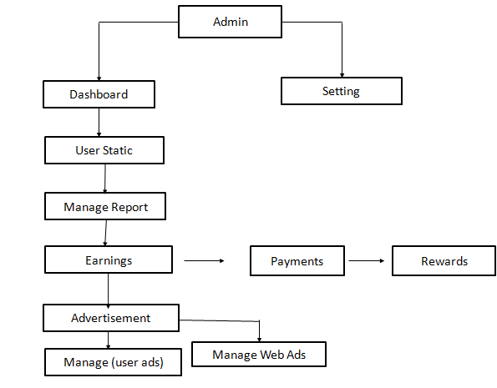

**Fig. Data Flow Diagram (1)**

This flowchart describe the admin module it has two parts Dashboard & Setting option in dashboard has various options such as user static ,Manage Report, Earning ,Advertisement, Manage user ads

The architecture of our platform uses the Inter-Planetary File System (IPFS) which is a decentralized file-sharing platform. In IPFS, involved parties have to establish a connection for the processes to be met. The feel of having close contact with a content creator brings with it a lot of desires that most fans will love to have. Every available decentralized application on the network will need to verify individuals who connect to the database for file retrieval. This serves as the basis on which individuals can get desired files. Music lovers’ will need to be confirmed and authenticated by the usage of their login credentials. This will be through the usage of the email address and password used for registration. Collected data will be saved and encrypted on the IPFS platform.

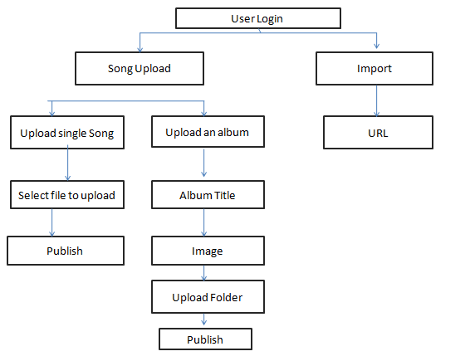

**Fig. Data Flow Diagram (2)**

This flowchart describe the User module it has two parts Song Upload & Import . Song Upload process goes throughs two stages i.e. Upload single song & Upload an album . In Import has URL options .

1. **Result Analysis**

**Home Page:**

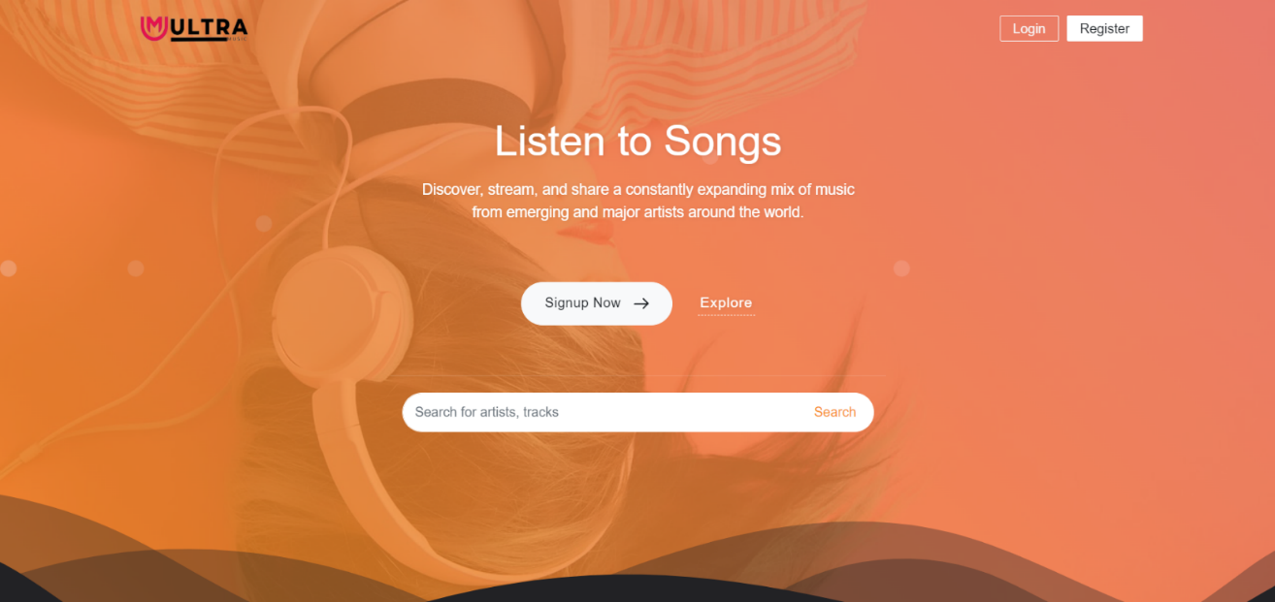

**Register Page:**

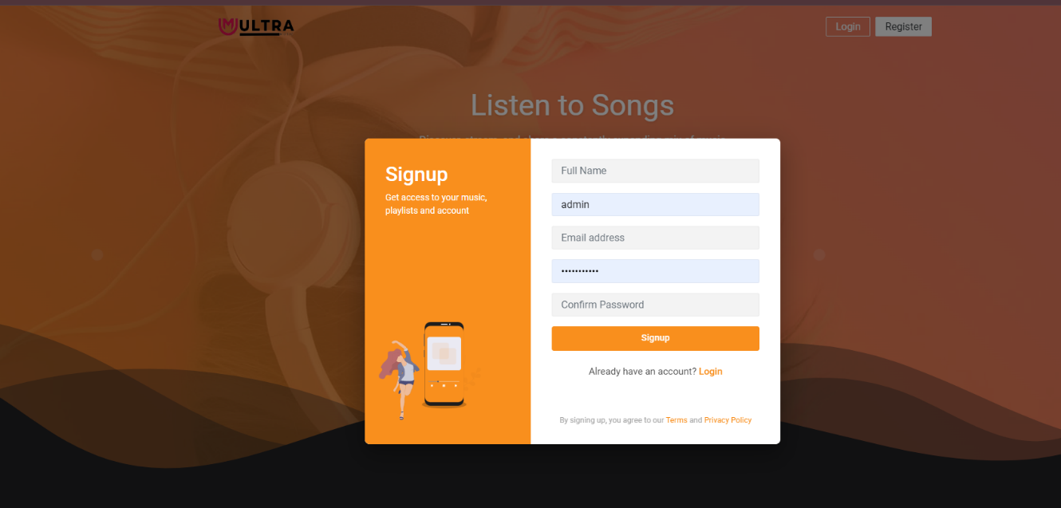

The first thing you will need to do is create a account on music sharing platform. You can do this by going to the website clicking “Sign Up” once you have created an account.

**Login Page:**

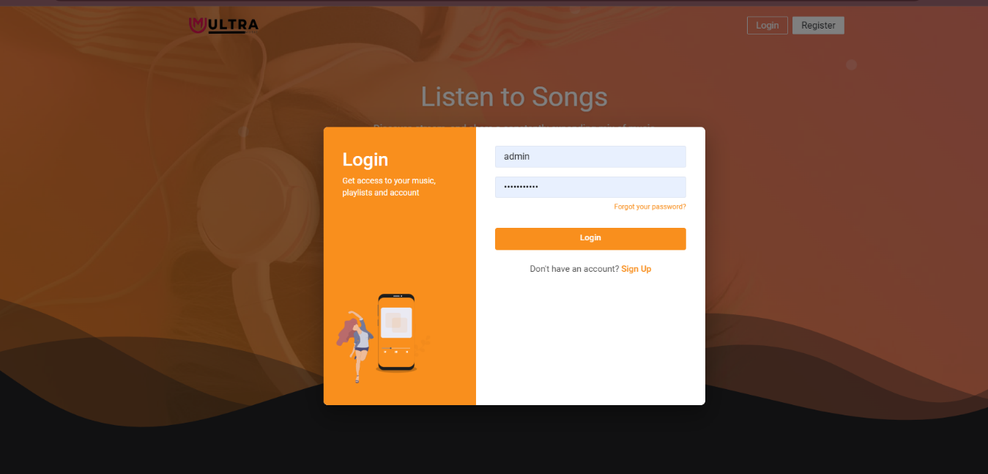

Click your name at the top-right, and then select account from the drop-down list that appears.

**Admin Panel:**

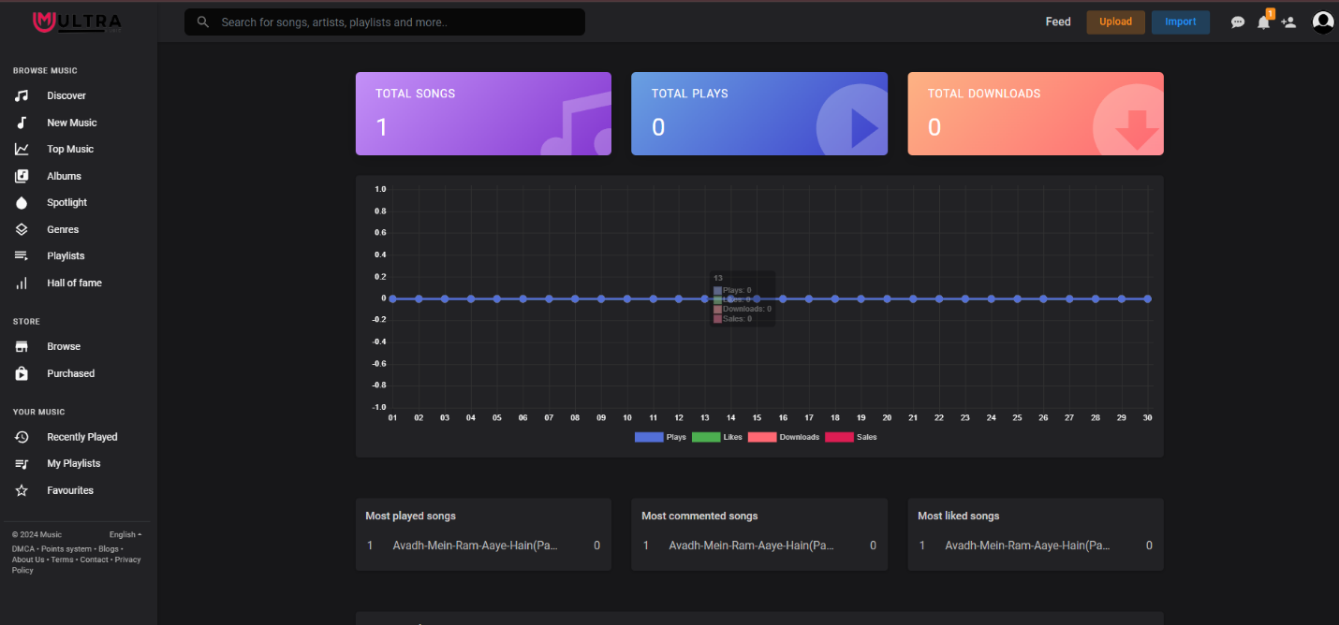

The admin contain the complete details about user and view the user information. There are some modules likes total songs , total users, and total playlist etc…..send the message to users .

**Discover Page:**

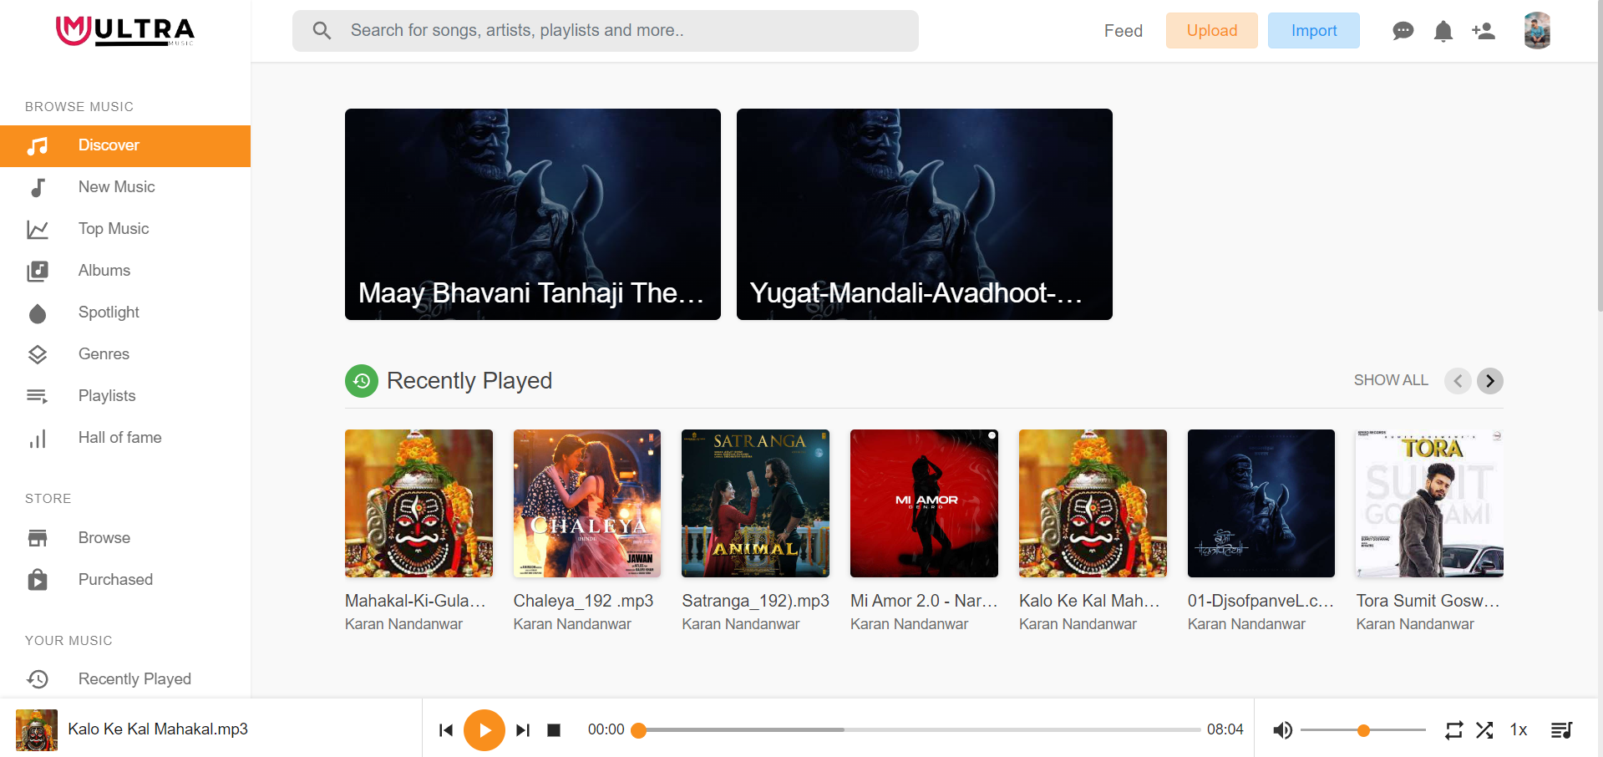

**Albums Page:**

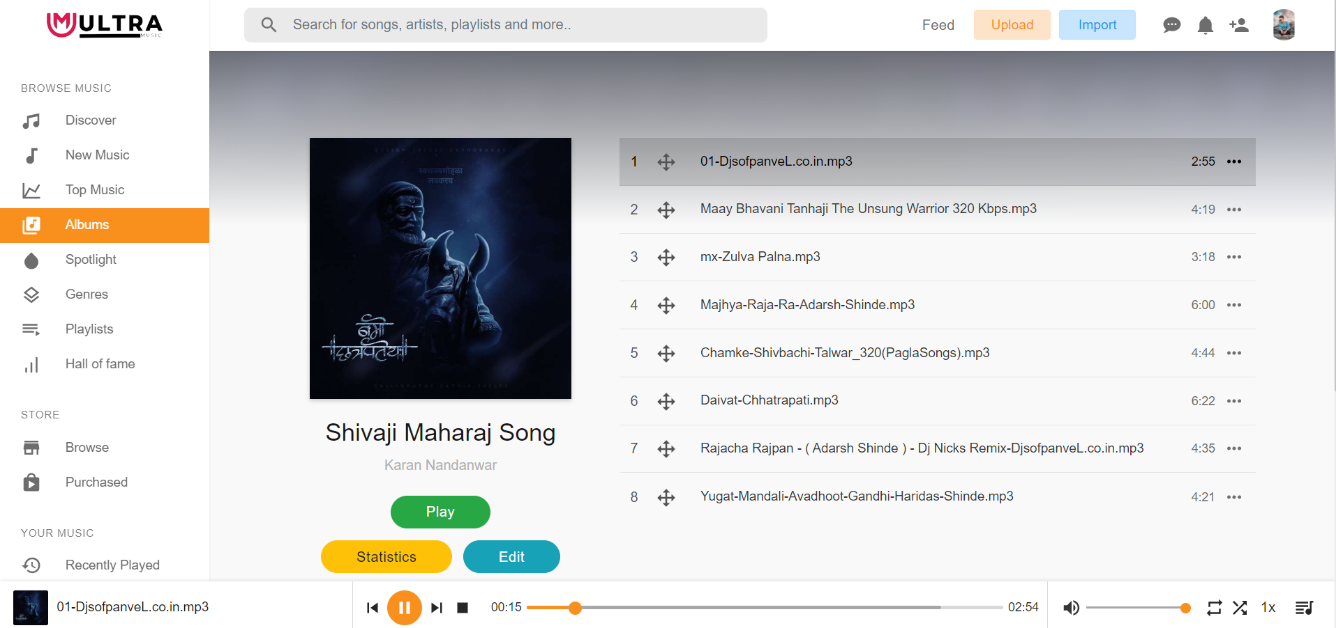

1. **DATA DICTIONARY**

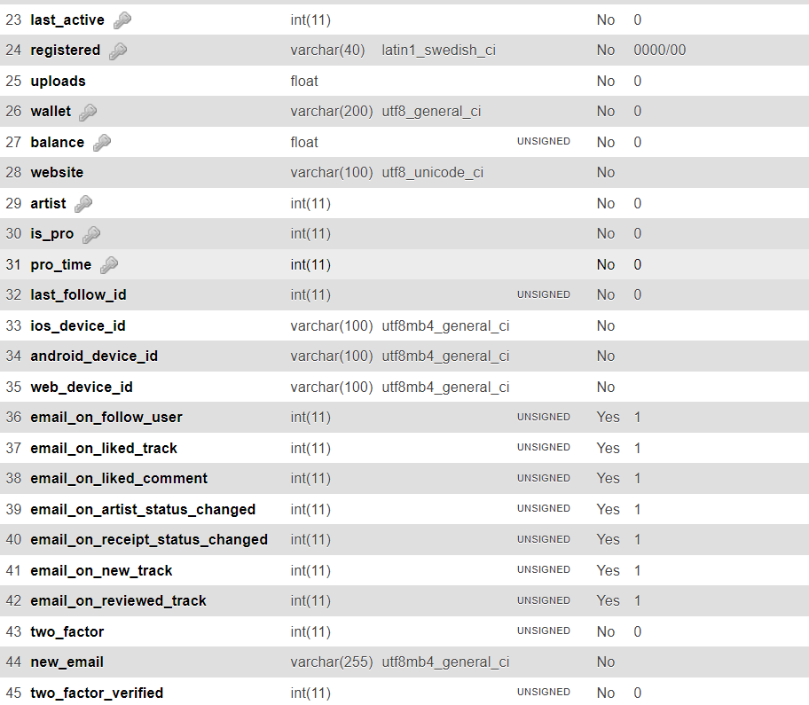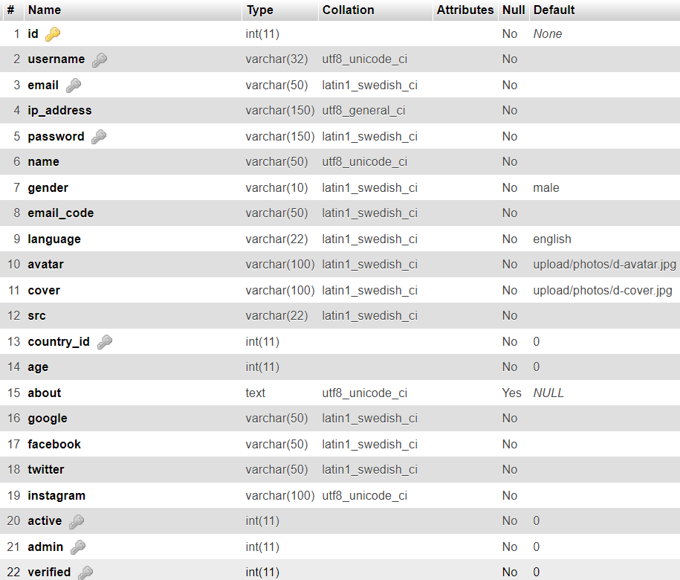

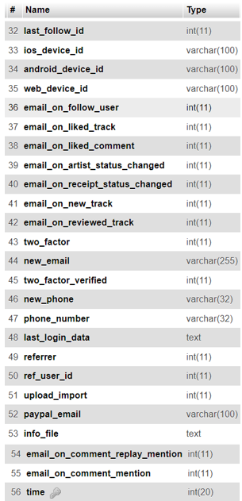

|  |  |  |  |
| --- | --- | --- | --- |
| **Sr. no** | **Data Element** | **Data Element Description** | **Data Type** |
| 1 | Primary   |  | | --- | | id | | Store id | int(11) |
| 2 | IndexIndex   |  | | --- | | username | | Store username | varchar(32) |
| 3 | email | Store email | varchar(50) |
| 4 | ip_address | Store ip_address | varchar(150) |
| 5 | Index   |  | | --- | | password | | Store   |  | | --- | | password | | varchar(150) |
| 6 | name | Store name | varchar(50) |
| 7 | gender | Store gender | varchar(10) |
| 8 | email_code | Store email_code | varchar(50) |
| 9 | language | Store language | varchar(22) |
| 10 | avatar | Store avatar | varchar(100) |
| 11 | cover | Store cover | varchar(100) |
| 12 | Indexsrc   |  |  | | --- | --- | |  |  | | Store src | varchar(22) |
| 13 | country_id | Store country_id | int(11) |
| 14 | age | Store | int(11) |
| 15 | about | Store about | text |
| 16 | google | Store google | varchar(50) |
| 17 | facebook | Store facebook | varchar(50) |
| 18 | twitter | Store twitter | varchar(50) |
| 19 | instagram | Store instagram | varchar(100) |
| 20 | Index   |  | | --- | | active | | Store active | int(11) |
| 21 | Index   |  | | --- | | admin | | Store admin | int(11) |
| 22 | IndexIndex   |  | | --- | | verified | | Store verified | int(11) |
| 23 | last_active | Store last_active | int(11) |
| 24 | Index   |  | | --- | | registered | | Store   |  | | --- | | registered | | varchar(40) |
| 25 | uploads | Store uploads | float |
| 26 | Index   |  | | --- | | wallet | | Store wallet | varchar(200) |
| 27 | Index   |  | | --- | | balance | | Store balance | float |
| 28 | website | Store website | varchar(100) |
| 29 | Indexartist | Store artist | int(11) |
| 30 | Index   |  | | --- | | is_pro | | Store is_pro | int(11) |
| 31 | Index   |  |  | | --- | --- | | pro_time |  | | Store pro_time | int(11) |
| 32 | last_follow_id | Store last_follow_id | int(11) |
| 33 | ios_device_id | Store ios_device_id | varchar(100) |
| 34 | android_device_id | Store android_device_id | varchar(100) |
| 35 | web_device_id | Store web_device_id | varchar(100) |
| 36 | email_on_follow_user | Store email_on_follow_user | int(11) |
| 37 | email_on_liked_track | Store email_on_liked_track | int(11) |
| 38 | email_on_liked_comment | Store email_on_liked_comment | int(11) |
| 39 | email_on_artist_status_changed | Store email_on_artist_status_changed | int(11) |
| 40 | email_on_receipt_status_changed | Store email_on_receipt_status_changed | int(11) |
| 41 | email_on_new_track | Store email_on_new_track | int(11) |
| 42 | email_on_reviewed_track | Store email_on_reviewed_track | int(11) |
| 43 | two_factor | Store two_factor | int(11) |
| 44 | new_email | Store new_email | varchar(255) |
| 45 | two_factor_verified | Store two_factor_verified | int(11) |
| 46 | new_phone | Store new_phone | varchar(32) |
| 47 | phone_number | Store phone_number | varchar(32) |
| 48 | last_login_data | Store last_login_data | text |
| 49 | referrer | Store referrer | int(11) |
| 50 | ref_user_id | Store ref_user_id | int(11) |
| 51 | upload_import | Store upload_import | int(11) |
| 52 | paypal_email | Store paypal_email | varchar(100) |
| 53 | info_file | Store info_file | text |
| 54 | email_on_comment_replay_mention | Store email_on_comment_replay_mention | int(11) |
| 55 | email_on_comment_mention | Store email_on_comment_mention | int(11) |
| 56 | time | Store time | int(20) |

1. **ADVANTAGES**

* They help you to access a vast variety of music.
* It helps the artists gain more popularity.
* Artists can authorize their content
* They prevent illegal music downloads.

1. **CONCLUSION**

In conclusion, creating and operating an online music sharing platform presents both opportunities and challenges. While such platforms offer a convenient way for users to discover, stream, and share music, they must navigate various hurdles to ensure success and sustainability.

The opportunities lie in providing users with access to a vast catalog of music, personalized recommendations, and interactive features that enhance the overall listening experience. By leveraging advanced technologies such as machine learning and data analytics, platforms can deliver tailored content and engage users in meaningful ways.

However, several challenges must be addressed to overcome the limitations inherent in such platforms. These include acquiring licensing rights for a comprehensive music library, optimizing infrastructure to handle high traffic volumes, ensuring compatibility across devices and operating systems, and implementing robust security and privacy measures to protect user data.

* The internet has much more power than the music industry today.
* Streaming and online music services have taken.
* over digital downloads and physical media
* As a result people have easy access to a wider range of music and are able to gain a following online via social media when sharing their own music challenging the traditional notion of record
* Our study of online digital music sharing highlights
* several key influential factors. Sharing audio files
* shows some similarities as well as uniqueness com-
* pared to software piracy. Price of music and available
* bandwidth are found to have significant effects on
* piracy. The price impact becomes more pronounced
* as technology improves. We find existence of piracy
* across all music categories, and weak evidence of sam-
* pling for “unknown” music. Interestingly, the per-
* ceived quality of compressed audio did not seem to
* play any significant role. We also find viability of sub-
* scription-based models, which exhibit sensitivity to
* gender differences and differentiated pricing based
* on bandwidth. These insights could influence
* enhanced pricing models in the future. Recent varia-
* tions of the subscription-based model, for example,
* Apple Computer’s à la carte online music service
* iTunes, are beginning to provide consumers greater
* flexibility in purchasing and listening to digital
* music.
* Other industries that produce digital goods and
* face similar problems need to be studied. In particu-
* lar, the TV and movie industry has already felt the
* pressure, and it is only a matter of better compression
* technology and increased bandwidth before full-
* length movies are shared the same way as music files
* [12]. The global scope of the Internet calls for the
* development of generalized models for information
* goods that are supranational and that transcend cul-
* tural, legal, and economic barriers.
* Our study of online digital music sharing highlights
* several key influential factors. Sharing audio files
* shows some similarities as well as uniqueness com-
* pared to software piracy. Price of music and available
* bandwidth are found to have significant effects on
* piracy. The price impact becomes more pronounced
* as technology improves. We find existence of piracy
* across all music categories, and weak evidence of sam-
* pling for “unknown” music. Interestingly, the per-
* ceived quality of compressed audio did not seem to
* play any significant role. We also find viability of sub-
* scription-based models, which exhibit sensitivity to
* gender differences and differentiated pricing based
* on bandwidth. These insights could influence
* enhanced pricing models in the future. Recent varia-
* tions of the subscription-based model, for example,
* Apple Computer’s à la carte online music service
* iTunes, are beginning to provide consumers greater
* flexibility in purchasing and listening to digital
* music.
* Other industries that produce digital goods and
* face similar problems need to be studied. In particu-
* lar, the TV and movie industry has already felt the
* pressure, and it is only a matter of better compression
* technology and increased bandwidth before full-
* length movies are shared the same way as music files
* [12]. The global scope of the Internet calls for the
* development of generalized models for information
* goods that are supranational and that transcend cul-
* tural, legal, and economic barriers.
* Our study of online digital music sharing highlights
* several key influential factors. Sharing audio files
* shows some similarities as well as uniqueness com-
* pared to software piracy. Price of music and available
* bandwidth are found to have significant effects on
* piracy. The price impact becomes more pronounced
* as technology improves. We find existence of piracy
* across all music categories, and weak evidence of sam-
* pling for “unknown” music. Interestingly, the per-
* ceived quality of compressed audio did not seem to
* play any significant role. We also find viability of sub-
* scription-based models, which exhibit sensitivity to
* gender differences and differentiated pricing based
* on bandwidth. These insights could influence
* enhanced pricing models in the future. Recent varia-
* tions of the subscription-based model, for example,
* Apple Computer’s à la carte online music service
* iTunes, are beginning to provide consumers greater
* flexibility in purchasing and listening to digital
* music.
* Other industries that produce digital goods and
* face similar problems need to be studied. In particu-
* lar, the TV and movie industry has already felt the
* pressure, and it is only a matter of better compression
* technology and increased bandwidth before full-
* length movies are shared the same way as music files
* [12]. The global scope of the Internet calls for the
* development of generalized models for information
* goods that are supranational and that transcend cul-
* tural, legal, and economic barriers.
* Our study of online digital music sharing highlights
* several key influential factors. Sharing audio files
* shows some similarities as well as uniqueness com-
* pared to software piracy. Price of music and available
* bandwidth are found to have significant effects on
* piracy. The price impact becomes more pronounced
* as technology improves. We find existence of piracy
* across all music categories, and weak evidence of sam-
* pling for “unknown” music. Interestingly, the per-
* ceived quality of compressed

**REFERENCES**

1. K. Mohamed and D. Wijeskera, "A lightweight framework for web services implementations on mobile devices", 2012 IEEE First International Conference on Mobile Services, 2012.
2. Brabec, Jeff, Brabec, Todd, 2018. Music Money and Success', Schirmer Trade Books, 8" Ed.
3. Passman, Donald S., 2019, 'All You Need To Know About the Music Business'. Simon & Schuster Publication, 10th Ed.
4. Hesmondhalgh, David, Jones, Ellis, & Rauh, Andreas. (2019). SoundCloud and Bandcamp as alternative music platforms. Social Media + Society, 5(4), 205630511988342. https://doi.org/ 10.1177/2056305119883429 IFPI. (2021). Global music report: Data and analysis for 2020
5. Jones, E. (2019). DIY and popular music: Mapping an ambivalent relationship across three historical case studies. Popular Music and Society, 44(1), 60–78. [https://doi.org/10.1080/03007766. 2019.1671112](https://doi.org/10.1080/03007766.%202019.1671112)
6. Caplan, R., & Gillespie, T. (2020). Tiered governance and demonetization: The shifting terms of labor and compensation in the platform economy. Social Media + Society, 6(2), 205630512093663. <https://doi.org/10.1177/2056305120936636>
7. Cooke, C. (2021). Tencent share price dips as Chinese regulator confirms exclusivity deal ban. Retrieved July 27, 2021, from https://completemusicupdate.com/article/tencent-share-pricedips-as-chinese-regulator-confirms-exclusivity-deal-ban/
8. Drott, E. (2018). Music as a technology of surveillance. Journal of the Society for American Music, 12(3), 233–267. <https://doi.org/10.1017/S1752196318000196>
9. Haynes, J., & Marshall, L. (2018). Beats and tweets: Social media in the careers of independent musicians. New Media & Society, 20(5), 1973–1993. <https://doi.org/10.1177/1461444817711404>
10. Hesmondhalgh, David. (2020). Is music streaming bad for musicians? Problems of evidence and argument. New Media & Society, 146144482095354. <https://doi.org/10.1177/1461444820953541>
11. Ingham, T. (2019). DIY artists will earn more than $1 billion this year. No wonder the major labels want their business. Retrieved December 12, 2020, from https://www.rollingstone.com/pro/ features/diy-artists-will-earn-more-than-1-billion-this-year-no-wonder-the-major-labelswant-their-business-830863/s
12. Drott, E. (2018). Music as a technology of surveillance. Journal of the Society for American Music, 12(3), 233–267. <https://doi.org/10.1017/S1752196318000196>